# A complete guide to create secure WCF REST API with custom Basic Authentication

Creating a WCF REST API services are still being used by many developers for client server connectivity for data and messaging. This blog is a complete guide on creating a WCF Rest service from scratch and Adding security to the service using Basic Authentication. Then we’ll learn how to encrypt the basic authentication information which would be sent over the network by applying SSL. The main sections of this guide are:

* Creating a WCF REST API service
* Hosting a WCF REST service in IIS from Visual studio (on local machine)
* Deploying a WCF REST service on IIS (Local machine)
* Adding security to the Service by using Basic Authentication
* Securing basic authentication credentials using SSL over Http i.e. (Https)
  + Creating a certificate and Enabling IIS website to use Https
  + Setting up WCF REST service to use SSL (Https)

Pre-requisite:

* Basic knowledge of Visual studio/WCF basics.
* Visual studio version > 2008
* .Net framework > 3.5 installed

## Creating a WCF REST API service

To get started quickly we’ll be using the default template of WCF service library provided in Visual studio 2013 which I’m using to create in this guide. Follow the steps below:

1. Launch visual studio 2013(choose **“Run as Administrator”**, we’ll see later why?)
2. From Menu **File** -> **New** -> **Project.** or click on Start Page to **start** a **New Project.**

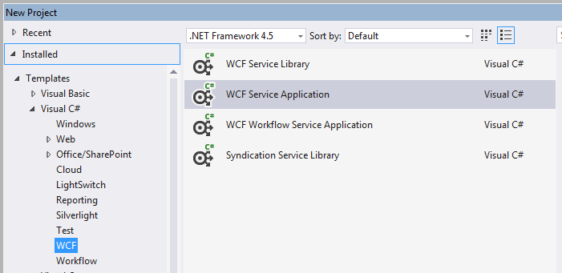

1. Let’s name it as WcfWebHttpIISHostingSample Now you’ll see couple of files already added to the Wcf Service project.

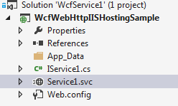

1. Delete **IService1.cs** and **Service1.svc** file as we’ll be creating new files and use our code to host the service via **ServiceHostFactory** class.
2. Add a new interface ITestService by right click on project and Add new item -> select Interface and rename it to **ITestService**. Copy below code and add it in newly created interface.

namespace WcfWebHttpIISHostingSample

{

[ServiceContract]

public interface ITestService

{

[WebInvoke(Method = "GET", UriTemplate = "/Data/{data}")]

string GetData(string data);

}

}

In above interface we have added WebInvoke attribute though we can also use WebGet it would not make any difference. I’ll stick with WebInvoke as it support other operations like POST, PUT, DELETE http verbs as well.

1. Add a new class TestService which will implement the above declared interface.

using System.ServiceModel;

using System.ServiceModel.Web;

using System.Web;

namespace WcfWebHttpIISHostingSample

{

[ServiceContract]

public interface ITestService

{

[WebInvoke(Method = "GET", UriTemplate = "/Data/{data}")]

string GetData(string data);

}

}

1. We have defined a service contract, a Rest method with a sample definition. Now we have to define its end points. To add end point simply copy the below settings to the configuration file under service.model tag.

<system.serviceModel>

<behaviors>

<serviceBehaviors>

<behavior name="ServiceBehavior">

<serviceMetadata httpGetEnabled="true" httpsGetEnabled="true"/>

<serviceDebug includeExceptionDetailInFaults="false"/>

</behavior>

</serviceBehaviors>

<endpointBehaviors>

<behavior name="webHttpServiceBehavior">

<!-- Important this is the behavior that makes a normal WCF service to REST based service-->

<webHttp/>

</behavior>

</endpointBehaviors>

</behaviors>

<services>

<service name="WcfWebHttpIISHostingSample.TestService" behaviorConfiguration="ServiceBehavior">

<host>

<baseAddresses>

<add baseAddress="http://localhost/WCFRestAuthentication/api/"/>

</baseAddresses>

</host>

<endpoint binding="webHttpBinding" contract="WcfWebHttpIISHostingSample.ITestService" behaviorConfiguration="webHttpServiceBehavior"/>

</service>

</services>  
</system.serviceModel>

1. Now we have an end point. So Next we’ll add a service host factory that will host the service in IISExpress or Local development server at this moment.
2. Add new item Global.asax and add following code in Application_Start method. You can find it Under New Item -> Web -> Global application Handler.
3. Now you’ll be getting an error ServiceRoute class in above code. To remove this error we have to add a new reference from Add reference -> Assemblies -> System.Model.Activation. And the error will be gone.
4. Now right click on Project and go to Properties. In properties window select Web and Add specific page details to map the service operation that we defined on our contract. Add [Data/HelloWorldTestData](http://localhost:49335/Data/HelloWorldTestData) in Specific page. Here Data is your path of operation and “HelloWorldTestData” is your argument that the service method will receive as argument. See below:

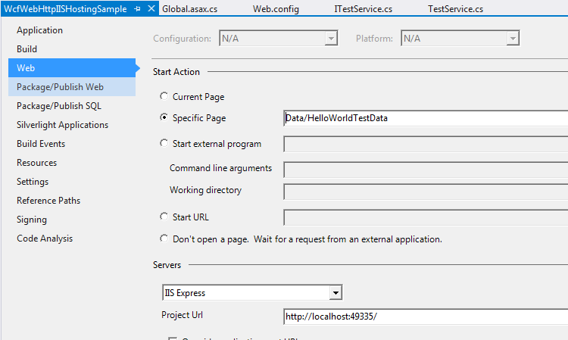

1. Save All and Press F5.

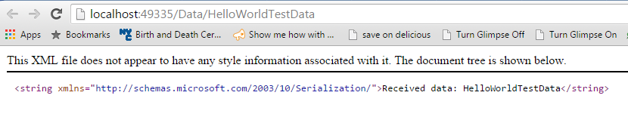

If you see a web page like below means you have successfully create and ran WCF REST service successfully.

## WCF REST service hosting in IIS

To Host the above service in IIS follow below steps:

1. Right click on the project and go to **Properties**. In properties window select **Web**.
2. Now under Servers on Web settings you’ll see following details change the “IIS Express” to “IIS Server”.



1. Now Click on **Create Virtual Directory.** Now if you have Visual Studio running As Administrator then you’ll get a message **The Virtual directory was created successfully!** Otherwise you’ll receive an error message and you need to launch again Visual studio as Administrator. I mentioned it in the start of this Guide.
2. Now press F5 and your website will be up and running on IIS server instead of your IIS express.

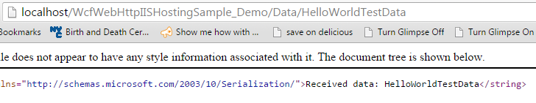

## Deploying a WCF REST service on IIS Local machine (optional)

(Optional) You don’t actually need to deploy the current WCF service because the visual studio already using IIS server for hosting. But this is just to let you know how to deploy a WCF REST service on IIS.

Follow below steps:

1. Right click on **Project** -> Goto **Publish**.
2. In Publish windows **open** the dropdown for profiles and select **New Profile**.
3. Select publish method as “Web Deploy”. Enter server as “Localhost”. Add site name as “**Default Web site/WcfWebHttpIISHostingSample_Demo2**”. Click Validate connection it’ll verify access rights and other information provided.
4. Once the Validate connection succeeds click publish. You’ll get the success message in output window in Visual studio.
5. Test the service by entering in browser following url - <http://localhost/WcfWebHttpIISHostingSample_Demo2/Data/TestingDeploymentSuccess>

## Adding Basic authentication

The REST services built and run over http protocol. A simple way to enable the authentication is to use **Basic** **Authentication**(i.e. user/pwd). Basic authentication can enabled over http protocol. Now here’s comes the choices that we have:

I can use simple transport level basic authentication by using Custom username and password **validator** as mentioned [here](http://blogs.msdn.com/b/phenning/archive/2008/01/11/custom-usernamepassword-validators-in-net-framework-3-5.aspx). But author explicitly stated that this will only work in self hosted environment. Which is not our case as we are using IIS to host our service. Also there are other method available on the internet like by extending **ServiceAuthenticationManager** or using a custom **MessageInspector** and use it like a custom user/pwd validator but I was not really convinced with those methods because somehow they were not fit for the candidate and our scenario. The challenge comes with this is that *IIS does the authentication before WCF receives the request.* And Till now there’s no out of the box support for Basic Authentication for WCF REST on IIS. So we have to go with our custom solution which by extending **ServiceAuthorizationManager** class and provide our method for **CheckAccess** and provide the custom class in Service Behaviors. The configuration would look something like below after providing a custom service Authorization.

<serviceBehaviors>

<behavior name="ServiceBehavior">

<serviceMetadata httpGetEnabled="true" httpsGetEnabled="true"/>

<serviceDebug includeExceptionDetailInFaults="true"/>

<serviceAuthorization

serviceAuthorizationManagerType

="WebHttpBehaviorExtensions.Security.RestAuthorizationManager, WebHttpBehaviorExtensions"/>

</behavior>

</serviceBehaviors>

Now I have to extend the class ServiceAuthorizationManager with a custom class RestAuthorizationManager which I named it to make sense with the context.

/// <summary>

/// Method source sample taken from here: http://bit.ly/1hUa1LR

/// </summary>

protected override bool CheckAccessCore(OperationContext operationContext)

{

//Extract the Authorization header, and parse out the credentials converting the Base64 string:

var authHeader = WebOperationContext.Current.IncomingRequest.Headers["Authorization"];

if ((authHeader != null) && (authHeader != string.Empty))

{

var svcCredentials = System.Text.ASCIIEncoding.ASCII

.GetString(Convert.FromBase64String(authHeader.Substring(6)))

.Split(':');

var user = new { Name = svcCredentials[0], Password = svcCredentials[1] };

if ((user.Name == "testuser" && user.Password == "testpassword"))

{

//User is authrized and originating call will proceed

return true;

}

else

{

//not authorized

return false;

}

}

else

{

//No authorization header was provided, so challenge the client to provide before proceeding:

WebOperationContext.Current.OutgoingResponse.Headers.Add("WWW-Authenticate: Basic realm=\"MyWCFService\"");

//Throw an exception with the associated HTTP status code equivalent to HTTP status 401

throw new WebFaultException(HttpStatusCode.Unauthorized);

}

}

This is it. Now your application is ready to challenge any request with Basic Authentication. To test it you can use any client like Fiddler or Chrome’s post man an see what outcome you get. So If I make request from normal browser I’ll get a challenge for basic authentication prompting user/password.

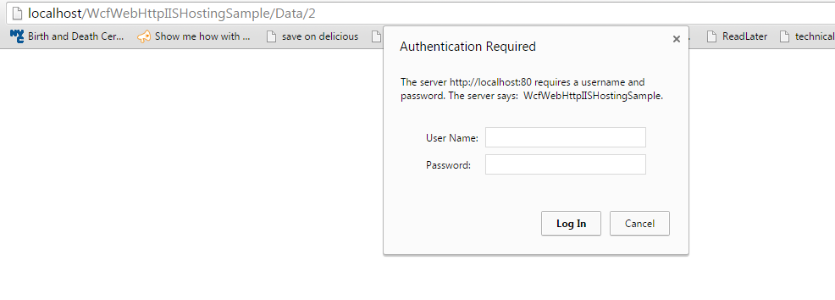

Enter the username -testuser and password –testpassword which we have used to validate the values in our RestAuthorizationManager.

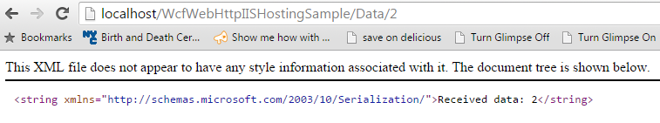

## Securing basic authentication credentials using SSL over Http i.e. (Https)

The Basic authentication information usually sent in plain text over the network. Most of the browser issue a warning about this secure information being sent as plain text. If you try to launch the API call in IE browser you’ll see a warning something like below:

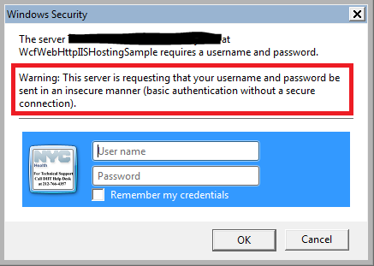

Here comes the Transport layer security into picture. All communication being done over the network can be secured using the Transport layer security by using [SSL(Secure Sockets Layer)](https://www.digicert.com/ssl.htm) certificates.   
To apply SSL security first you need a certificate. In order to get a certificate one can go to certificates providers like Thawte, digicert, Godaddy etc. and purchase a certificate. These providers (not mentioning any specific provider but all in general) are trusted providers for issuing digital certificates to ensure that identity of authority is verified.

But in development environment you don’t need to purchase a SSL certificate in real. You can generate a local self-signed certificate from your machine. But the certificate would be only valid for your local use only. If you use the certificate over the network this would be invalidated. I’m not going into details so let’s get started how to get a self-signed server certificate that you can use in development environment.

## Creating a certificate and enabling the Https settings to use the certificate

You have two options either create a certificate using ‘[makecert](https://msdn.microsoft.com/en-us/library/bfsktky3(v=vs.110).aspx)’ command. [Here’s](http://www.digitallycreated.net/Blog/38/using-makecert-to-create-certificates-for-development) a nice detailed article with quite good explanation about certificates. Or you can use IIS 7.0 or greater to create your certificate.

1. Launch Internet Manager from control panel or goto Run -> type ‘**Inetmgr’** -> press enter.
2. Select the ROOT node on left side panel. Look for **`Server Certificates`** under `**IIS**` on right panel.

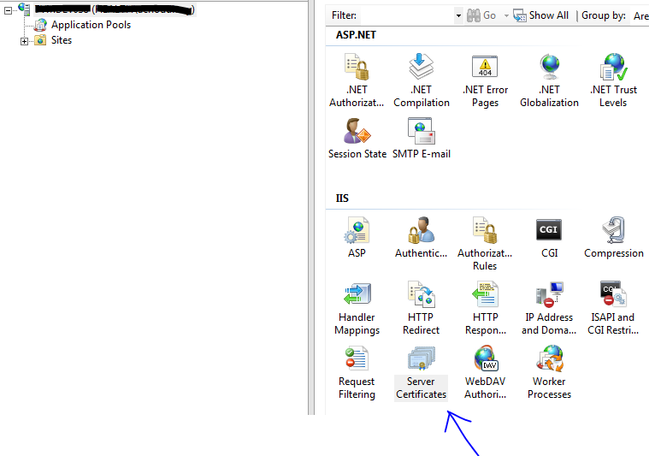

1. Double click on ‘**Server Certificates’** and select **‘Create self-signed certificate’**.

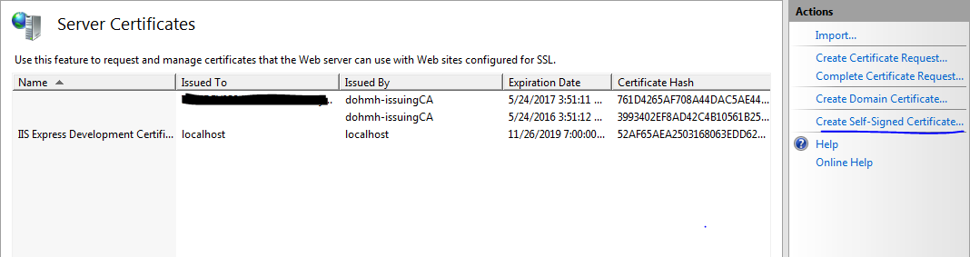

1. Now enter the name of certificate. This will be the friendly name of your certificate.

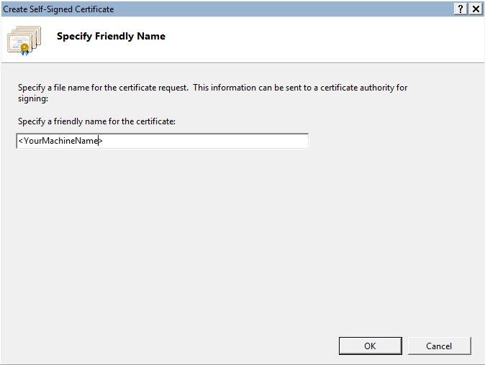

1. Click Ok and certificate that you have created would appear in parent window.
2. Now **select** the **website** you want to configure for HTTPS in IIS.

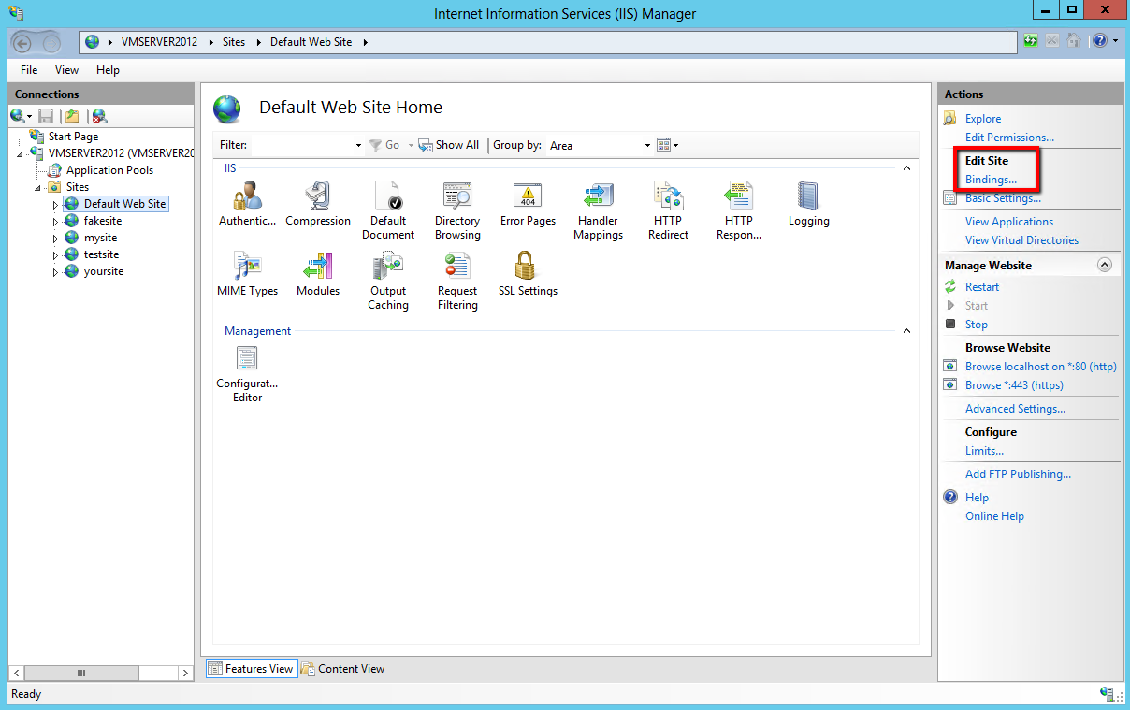

1. In the **Site Bindings** window, click **Add**.



1. In the **Add Site Binding** window, enter the following information:

|  |  |
| --- | --- |
| **Type**: | In the drop-down list, select **https**. |
| **IP address:** | In the drop-down list, select All Unassigned. |
| **Port:** | Enter 443. The port for SSL traffic is usually port 443. |
| **SSL certificate:** | In the drop-down list, select your recently imported SSL Certificate by its friendly name. |

1. Click OK. Your SSL Certificate is now installed and the website is configured to accept secure connections.

**Note:** You may have to restart IIS or the server for it to recognize the new certificate. And your local signed certificate is configured and ready to use.

1. To test the setting click on ‘Browser’. You might see below error.

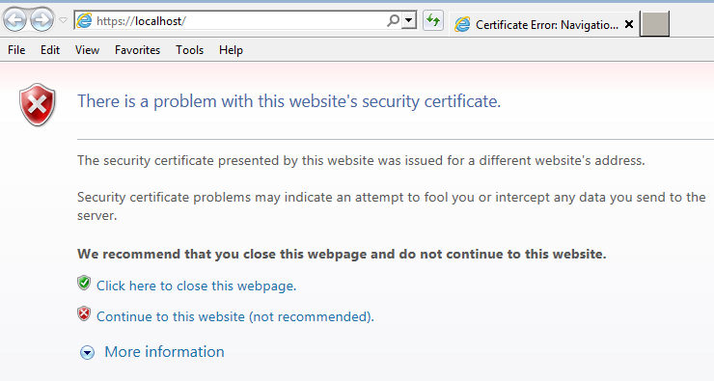

1. To get rid of this error use the machine name exactly which your certificate section “Issued to” says. E.g. If you open your certificate then you’ll see **issued to** property and which should be your Machine name. If your machine is part of a domain then machine name would be like <machinename>.<xyz>.<domain> etc. Use the name exactly show in Issued **To property**.

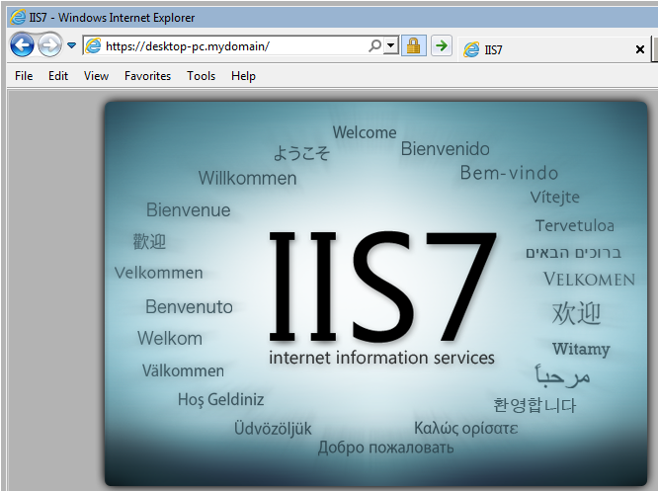

**Note**: It is important to use these names only as domain name should match with certificate name when hosting the WCF REST service in IIS.

## Setting up WCF REST service to use SSL (Https)

To enable the SSL over Http protocol follow below steps:

1. Add Protocol mapping for the webhttpbinding to use https.

<protocolMapping>

<add binding="webHttpBinding" scheme="https"/>

</protocolMapping>

1. Under **binding** -> **webhttpbindings** enable security mode **Transport**.

<bindings>

<webHttpBinding>

<binding name="customHttpBinding" contentTypeMapper="WebHttpBehaviorExtensions.TypedUriTemplateBehaviorWebContentTypeMapper, WebHttpBehaviorExtensions, Version=1.0.0.0, Culture=neutral, PublicKeyToken=Null">

<security mode="Transport" />

</binding>

</webHttpBinding>

</bindings>

1. Add a host base address under services -> service.

<service name="WcfWebHttpIISHostingSample.TestService" behaviorConfiguration="ServiceBehavior">

<host>

<baseAddresses>

<add baseAddress="https://desktop-pc.mydomain/WcfWebHttpIISHostingSample/api/"/>

</baseAddresses>

</host>

…

…

</services>

1. Now rebuild the service and test it in the browser. You will not see the warning of in-secure message any more.

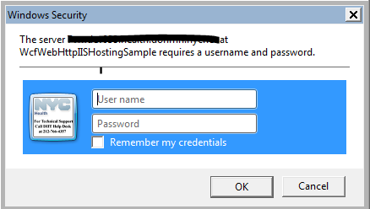

I hope this article will helped you. Feel free to like share. The complete sample used in this Guide can be found [here](https://github.com/vendettamit/WebHttpBehaviorExtensions) on Github.